**Github guide for Gathe development**

**Preparation**

for first clone, use this command:

* for web:

> git clone https://github.com/OlympusProject/GatheWeb.git

* for mobile:

> git clone https://github.com/OlympusProject/GatheMobile.git

* for backend:

> git clone https://github.com/OlympusProject/GatheService.git

* for design:

> git clone <https://github.com/OlympusProject/GatheResource.git>

if you already clone, please make sure you are under branch develop using command:

> git status

for example:

key@debian:~/Documents/Project/Mix/Gathe/GatheService$ git status

On branch develop

nothing to commit, working tree clean

key@debian:~/Documents/Project/Mix/Gathe/GatheService$

if your branch is still on master, please switch your branch to develop using command:

> git checkout develop

if branch develop is not yet exist, you can create and switch using command:

> git checkout -b develop

**Start Development (for mobile, web and backend)**

for development a new feature, please create a feature branch under develop (make sure your branch is already on develop before create a new branch using git status) using command:

> git checkout -b feature/<your_name>-<new_feature_name>-<environment>

noted: environment is mobile/web/service

for example:

> git checkout -b feature/krisna-login-service

after that, please make sure you branch is already switch using git status.

After your development, you can add and push your code to your feature branch using command:

> git add .

> git commit -m “your commit message”

> git push origin feature/<your_name>-<new_feature_name>-<environment>

for example:

> git add .

> git commit -m “first initialize commit for login feature in backend”

> git push origin feature/krisna-login-service

warning: please don’t push your development on branch develop or master

**Code Review**

after push your development on your feature branch, please ask to another people to review your code and tell the name of your feature branch to the reviewer.

Step to review the code:

open link for compare in repository github:

* web: <https://github.com/OlympusProject/GatheWeb/compare>
* backend: <https://github.com/OlympusProject/GatheService/compare>
* mobile: <https://github.com/OlympusProject/GatheMobile/compare>

compare the feature branch with develop branch.

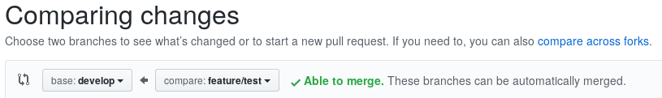

Note: anyone can try to review code from another people and give comment in github.

After code review is done, the code will be pushed on develop branch by PIC of develop branch to test.